Instructions to create the parse_###.mat files:

1. Open up the data_###.txt file.
2. Open Matlab.
3. In the top right area, click on New variable.  
   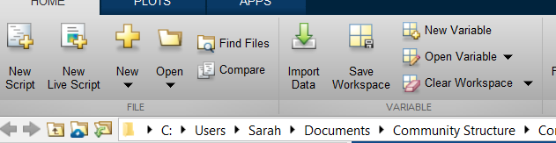
4. In the text file, scroll down past the first part until you get to row 1400. Copy (Ctrl-C) the next 600 rows (where it resets to 1, through 600. These are the 600 trials in the response portion of the experiment).  
   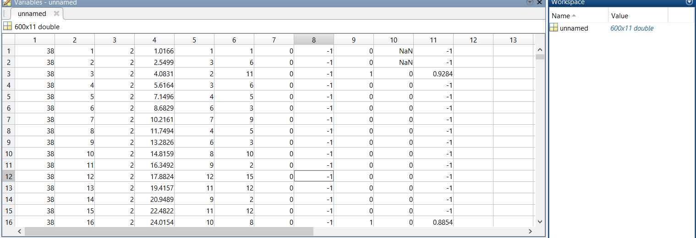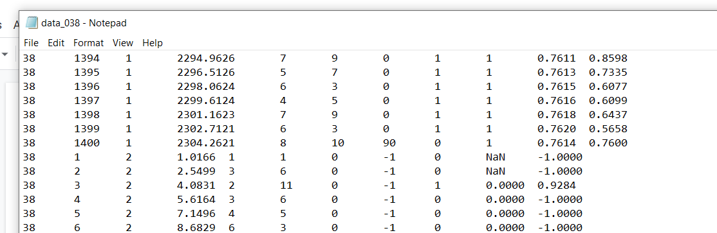
5. Paste those 600 rows into the New variable you just created in Matlab
6. In the workspace on the right, right click on the variable where it says unnamed and rename it to parses
7. On the home tab at the top, press save workspace and save it as parses_### (the subject number).mat in the right folder.
8. Before you move on to doing this for another subject, make sure you clear the workspace! There is a button for this on the home tab near the top right.